

Automatic Filter Drain

Models:
FF-DV-V-100F/S and FF-DV-P-100F/S

User Guide
8 Executive Drive
Toms River, N.J. 08755
Phone: 800-337-3762
732-244-0010
Fax: 732-244-8140
E-mail: info@permapure.com
Web Site: www.permapure.com
Perma Pure Automatic Filter Drain System

For vacuum service:
Models FF-DV-V-100F (fluorocarbon) and FF-DV-V-100S (316 Stainless Steel)

For pressure service (15 psig max on F model, 60 psig max. on S model.)
Models FF-DV-P-100F (fluorocarbon) and FF-DV-P-100S (316 Stainless Steel)
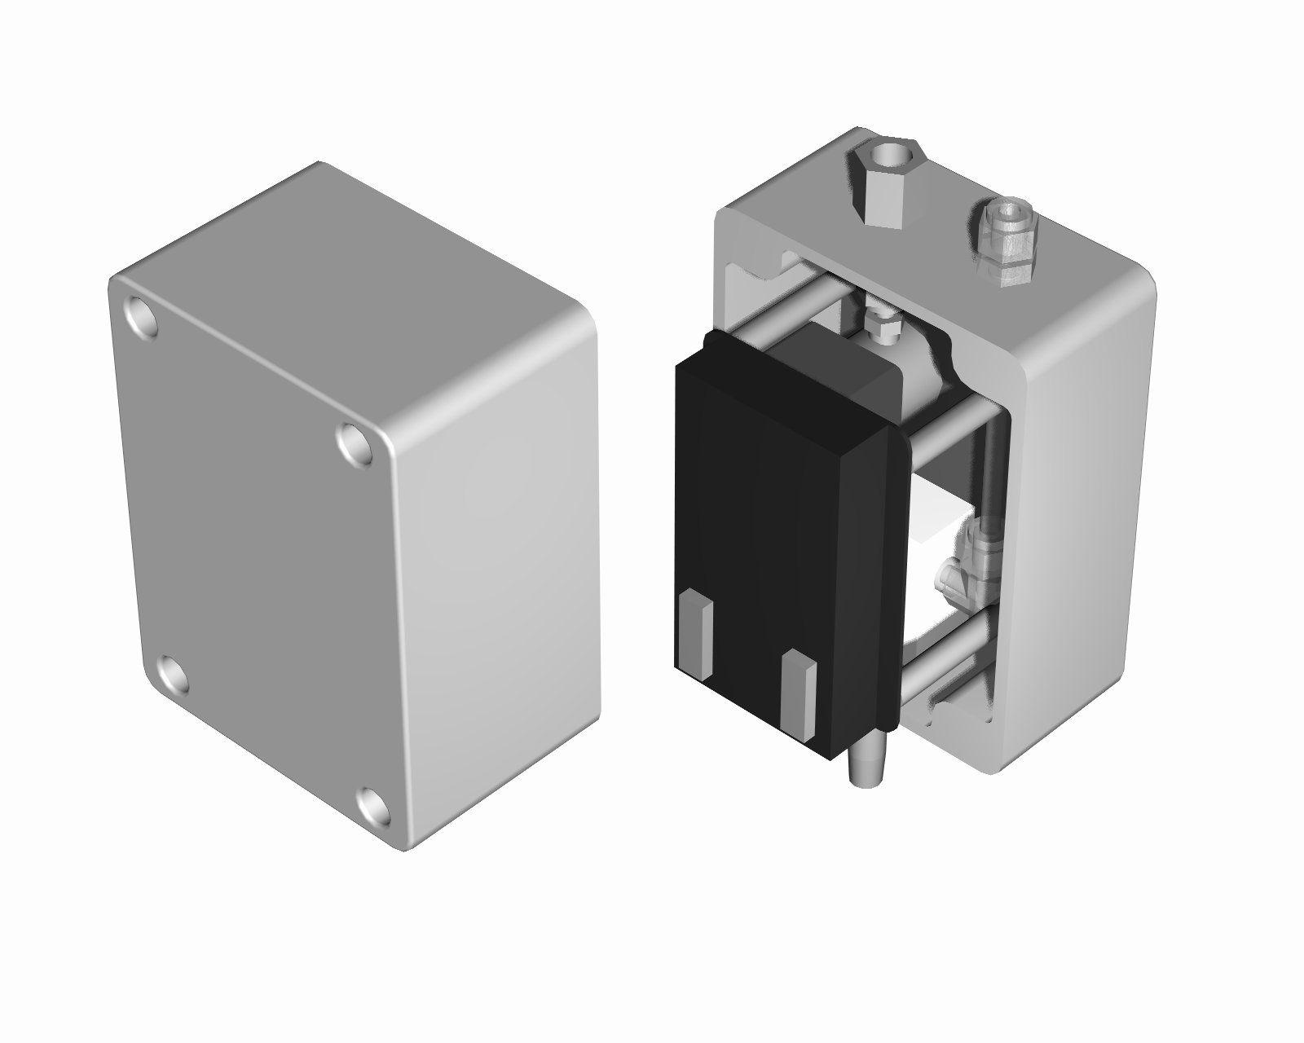
Condensate/air exhaust port,
¼” NPT male pipe(vacuum version)
¼” compression(pressure version)
Compressed air inlet(vacuum version only),
¼” NPT female pipe, 100 psig max.
Condensate suction port,
¼” compression
ABS plastic screw cover
ABS plastic enclosure
Dimensions 4.75w”,6.25h”,5.5d”
NEMA 1,2,3,3R,4,4X,5,12,&13
IP 65,DIN 40050

Solid state timer with DIP switches for cycle and drain time adjustment
AC power cord connection
Filter Drain Timer Control

The automatic filter drain is controlled by a repeat-cycle-timer that operates a solenoid valve. There are two DIP switches located on the timing device that controls the drain and cycle times.

Standard factory setting is to drain for 0.1 minute once every 1.0 hours.

Drain time (left DIP switch) 0.1 minutes (1st switch on – all others off)
to
102.3 minutes (all switches on)

Cycle time (right DIP switch) 1 hour (1st switch on – all others off)
to
1023 hours (all switches on)

Initially adjust the DIP switches on the drain timer to drain for 6 seconds every 24 hours. The time on the switches is additive. So, the left switch should have only the top 0.1 min. switch in the on position and the right switch should have the 8 and 16 hr. switches in the on position. These time periods may need further adjustment after the system has been in operation for a while. The amount of time set on individual dipswitches is additive. For instance, if it is desired to set the drain time to ½ minute, both the 0.1 and 0.4 switches on the left dipswitch should be in the on position.

Operation

- Vacuum models: A pressure regulator supplies air to the eductor solenoid valve. When energized by the timer, the eductor creates a vacuum that draws condensate from the filter through the check valve and out to the drain line. The regulator must be set to provide ample vacuum to remove the filter condensate but not excessive enough to cause an interruption in the sample flow through the filter. The presence of the check valve is required to prevent back flow of air into the filter while the eductor is not in use.

- Pressure models: The condensate drain flow is directly controlled by a solenoid valve. When the solenoid valve is energized, the positive pressure in the filter housing pushes the condensate out of the system through the drain line.

